grafik, daire, grafik tasarım, ekran görüntüsü içeren bir resim

Açıklama otomatik olarak oluşturuldu

**Atilim University Software Engineering Department**

**SE-112 Introduction to Software Engineering**

**2023-2024 Spring Semester**

**Project: Online Election System**

Members: Atacan İSHAN 23244710028

Çoruh Sarp ACAR 23244710067

Baran Kemal YAZICI 22244710023

Project / Group No: 7

Table Of Contents

1. Project Proposal - 1 -

1.1 Project Budget - 1 -

1.2 Monitoring and Evaluation - 2 -

2. Project Management - 3 -

2.1 Project Plan - 3 -

2.2 Risk Plan - 3 -

3. Project Requirements - 5 -

3.1 User-Story - 5 -

3.2 Use-Case Diagram - 6 -

3.3 Class Diagram - 7 -

3.4 Activity Diagram - 8 -

3.5 User Interfaces - 9 -

# Project Proposal

The aim of our project is to make the process during and after the elections more reliable, more accessible and to ensure that everyone can access the election results easily and quickly. That is why we decided to develop such an election system. The Online Election System is a web-based system designed for voters and candidates. Our system will include features such as voter registration and identity verification, as well as tabulation and instant updating of results. Our system will use a new technology, blockchain. In this way, we will strengthen user privacy. Our scope is: Voter who wants to vote enters the system, he/she will vote securely after going through some verification processes (E-Devlet, etc.). We will use Agile Software Development Methodology while developing this software Project. Ensuring a clean, reliable and fair election process after the system is put into use. Our objectives are:

* Enable voters who cannot vote due to transportation difficulties to vote.
* Facilitate voting for voters who cannot vote due to physical disabilities.
* Trying to remove election frauds.
* Eliminate the environmental and economic damage caused by ballot papers.
* Eliminate psychological pressure from the environment when voting.

## 1.1 Project Budget

|  |  |  |
| --- | --- | --- |
|  | Description of Work | Anticipated Costs |
| Phase One | This first phase involves research development, planning, task distribution, providing the appropriate environment, equipment and seeking expert advice. | 13,500**$** (R&D Engineers)  10,500**$** (Office Rent)  9,000**$** (Advisors(Analyst))  10,000**$** (Equipments) |
| Phase Two | At this stage, while the project is being developed, it includes costs such as employee costs, labor costs, travel expenses, etc. | 25,000**$** (Software Engineers)  12,500**$** (Providing Transportation and Meals) |
| Phase Three | At this stage, it includes expenses such as testing the system, detecting bugs, resolving bugs, quality control measures, maintenance costs that may be incurred in the future, and conducting the market research required to release the system. | 7,500**$** (Advertising and Market Research)  37,500**$/Per Year** (Maintenance) |
|  | **Total** | **$ 125,500** |

## 1.2 Monitoring and Evaluation

Our project will be developed in accordance with the Agile Software Development Methodology in **Figure 1.**

ekran görüntüsü, daire, metin, grafik içeren bir resim

Açıklama otomatik olarak oluşturuldu**Figure 1**

**(https://www.smartsheet.com/understanding-agile-software-development-lifecycle-and-process-workflow)**

# Project Management

In our project, we made the project plan carefully. The next heading is our project plan.

## Project Plan

**metin, ekran görüntüsü, öykü gelişim çizgisi; kumpas; grafiğini çıkarma, çizgi içeren bir resim

Açıklama otomatik olarak oluşturuldu**

**Figure 2**

## 2.2 Risk Plan

The risk plan will provide a solid basis for the healthy progress of the project. This risk plan will help to minimize the disruptions that may occur in the project management process in case of economic difficulties of the company, poor health of employees or transportation difficulties.

According to the risk plan, risks will be divided into 3 groups. These are:

**High** – Risk that has the potential to greatly impact project cost, project schedule or performance·

**Medium** – Risk that has the potential to slightly impact project cost, project schedule or performance·

**Low** – Risk that has relatively little impact on cost, schedule or performance.

**Some risks that may occur:**

1. Conflicts may occur between employees during the project. (Medium)

**B-Plan:** Organizing regular social events among employees.

1. Technical problems may occur during the project phase. (Medium)

**B-Plan:** Maintain regular backups of critical documents.

1. The project may not be completed in the expected time. (High)

**B-Plan:** Explaining the situation to the customer in advance.

1. The project may not meet customer requirements. (High)

**B-Plan:** Provide regular feedback to the client on the project.

1. A strategically wrong plan can be made. (High)

**B-Plan:** Keeping our plan constantly updated and organized by making accurate, appropriate analyzes.

1. Employees may not be in good psychological or physical health. (Low)

**B-Plan:** Distributing the sick worker's work equally to other workers.

1. There may be departures from the team implementing the project. (Medium)

**B-Plan:** Spend an overtime to search for qualified new employees.

1. New employee adjustment problem. (Low)

**B-Plan:** Organizing regular social events among employees.

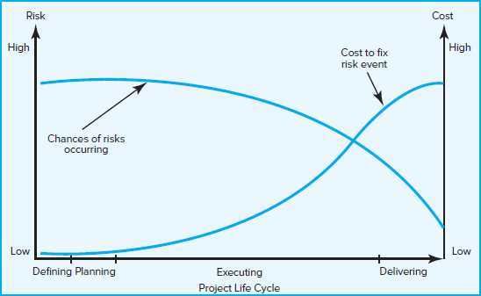 Figure 3

(https://mymba.com.au/project-management/project-management-week-5-managing-risk-and-managing-project-teams/)

## Project Requirements

|  |  |  |
| --- | --- | --- |
| Functional Requirements | Explanation | MOSCOW priority (M,S,C,W) |
| Functional Req 1 | The system should ensure that voter information is verified through the state system. | MUST |
| Functional Req 2 | The user will be able to access the system from any point where they access the internet. | MUST |
| Functional Req 3 | There will be a text with the candidates' promises. | SHOULD |
| Functional Req 4 | The emblems of the parties participating in the elections and the pictures of the candidates will be presented to the voters. | MUST |
| Functional Req 5 | The system will provide detailed reports on turnout, demographics and voting trends. | COULD |
| Functional Req 6 | It automatically counts the votes and announces the results when voting is over. | MUST |
| Functional Req 7 | The system blocks voting for more than one candidate and party on one ballot. | MUST |
| Functional Req 8 | The system won't show the vote count during the election process. | WON’T |
| Functional Req 9 | Receives user feedback about the system. | SHOULD |
| Functional Req 10 | Voters are educated about the platform and the election. | COULD |
| Non-Functional Requirements | Explanation | MOSCOW priority (M,S,C,W) |
| Non-Functional Req 1 | The system secures the user's information and data by blockchain. | MUST |
| Non-Functional Req 2 | The system serves the user without slowdowns or interruptions. | MUST |
| Non-Functional Req 3 | It will be ensured that the vote will not be shared through the 3rd party. | WON’T |

## User-Story

Story: The voter enters the system and verifies their information through the state system. After being informed about the system and the election, the voter sees the promises of the parties and candidates and casts his/her vote After using the vote, he can give feedback about the system if he wants. User can see the election results and detailed analysis after the election is over.

## Use-Case Diagram

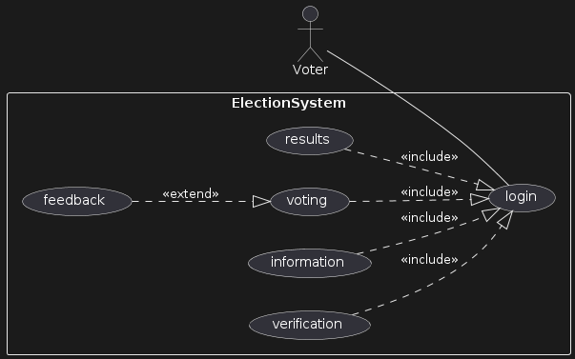

@startuml

actor Voter

top to bottom direction

left to right direction

rectangle ElectionSystem{

usecase login

usecase verification

usecase information

usecase voting

usecase feedback

usecase results

}

Voter -- (login)

verification ..|> (login):<<include>>

information..|>(login):<<include>>

voting ..|> (login):<<include>>

feedback ..|>(voting):<<extend>>

results ..|>(login):<<include>>

@enduml

Meaning of diagram: Actors are Voters and tasks are “login”, “verification”, “information”, “voting”, “feedback”, “results”

## metin, ekran görüntüsü, diyagram içeren bir resim Açıklama otomatik olarak oluşturulduClass Diagram

@startuml

class Voter {

- id: int

- name: String

- password: String

+ getInformation(): void

- vote(candidate: Candidate): void

}

class Results {

+ electionWinner: Candidate

+ totalVotes: int

+ determiningTheWinner(candidate: Candidate): void

}

class Voting {

+startVote(): void

+endVote(): void

}

class Login {

+ login(id: int, password: String): boolean

}

class Information {

+ giveInformation(): String

}

class Verification {

+ voterVerification(voter: Voter): boolean

}

class Feedback {

- feedback: Array<String>

+ giveFeedback(feedback: String):void

+ displayFeedbacks(): void

}

Voter "1"--"1" Verification: Association

Voter "1"--"1" Login: Association

Feedback *-- "1" Voter: composition

Candidate o-- "1" Results: aggregation

Voter "1" o-- "*" Candidate: aggregation

Voting "1" -- "1" Results: association

Information "1" -- "1" Results: association

Results "1" o-- "*" Candidate: aggregation

@enduml

## metin, ekran görüntüsü, diyagram içeren bir resim Açıklama otomatik olarak oluşturuldu3.4 Activity Diagram

@startuml

start

:Login;

-> Enter ID, user name and password;

if (Is the user matched?) then (yes)

:Show participating parties;

:User selects a parties;

:Show party promises and candidates;

if (Does the user want to vote?) then (yes)

:Show voting options;

:User votes;

if (Vote successful?) then (yes)

:Show thank you message;

else (no)

:Show error message;

endif

else (no)

:Empty Vote;

endif

else (no)

: Show Error warning;

endif

stop

@enduml

## 3.5 User Interfaces

<https://www.figma.com/proto/2EhTBOMFz4ONQWHh3hlQjB/Se-112-Election-System-UI?type=design&node-id=1-158&t=EHmjxJm6wxMspXgO-1&scaling=scale-down&page-id=0%3A1&starting-point-node-id=1%3A158&mode=design>

metin, ekran görüntüsü, mobil telefon, mobil cihaz içeren bir resim

Açıklama otomatik olarak oluşturuldumetin, ekran görüntüsü, mobil telefon, mobil cihaz içeren bir resim

Açıklama otomatik olarak oluşturuldu